A000-Indo-Sumatra-Batak People-Shaman Mask-Water Buffalo Bone-1890’s

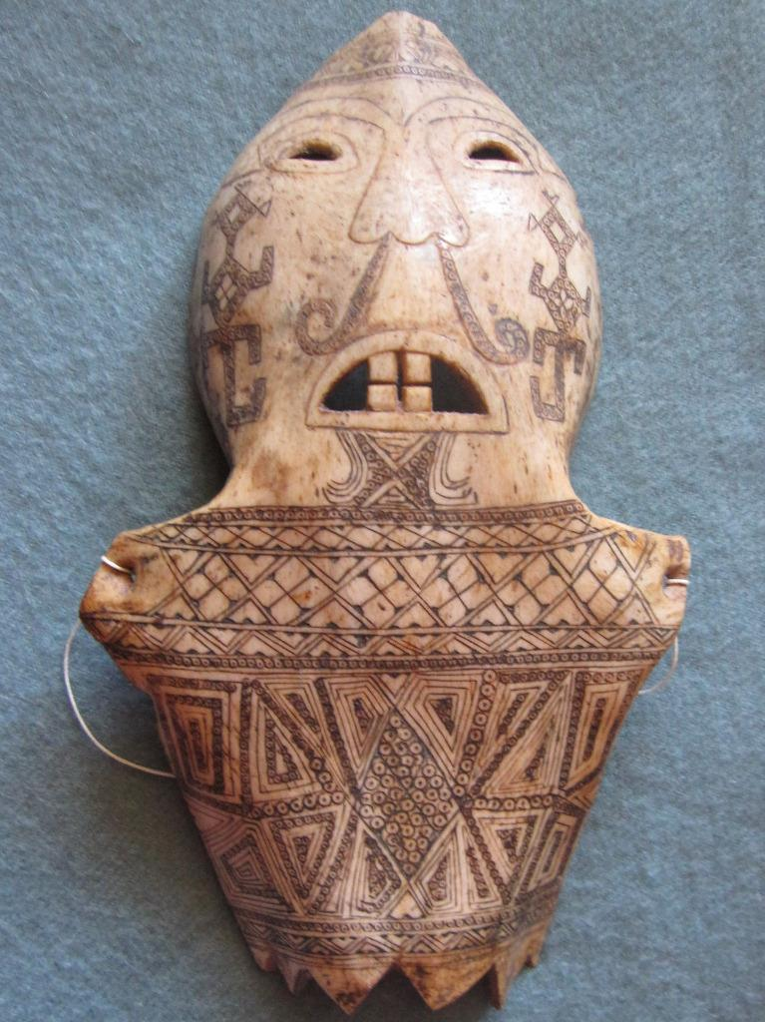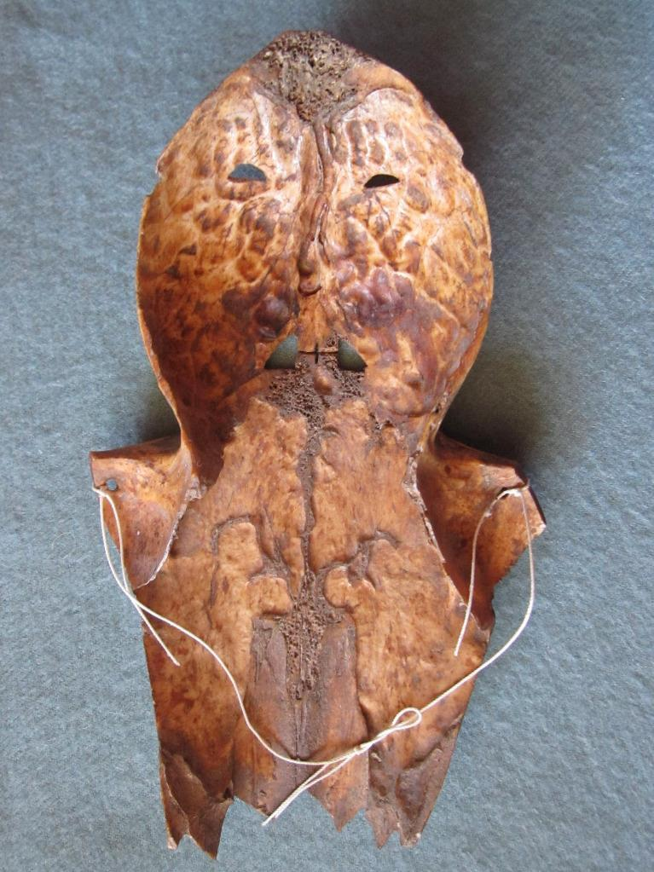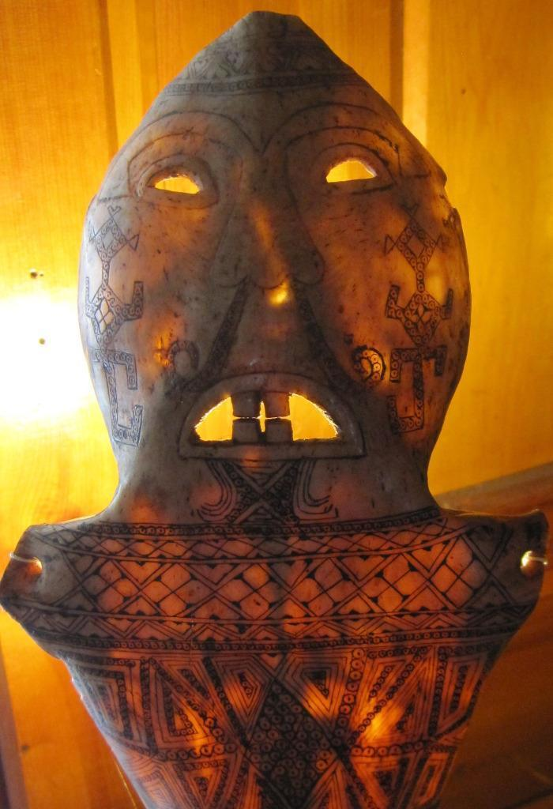

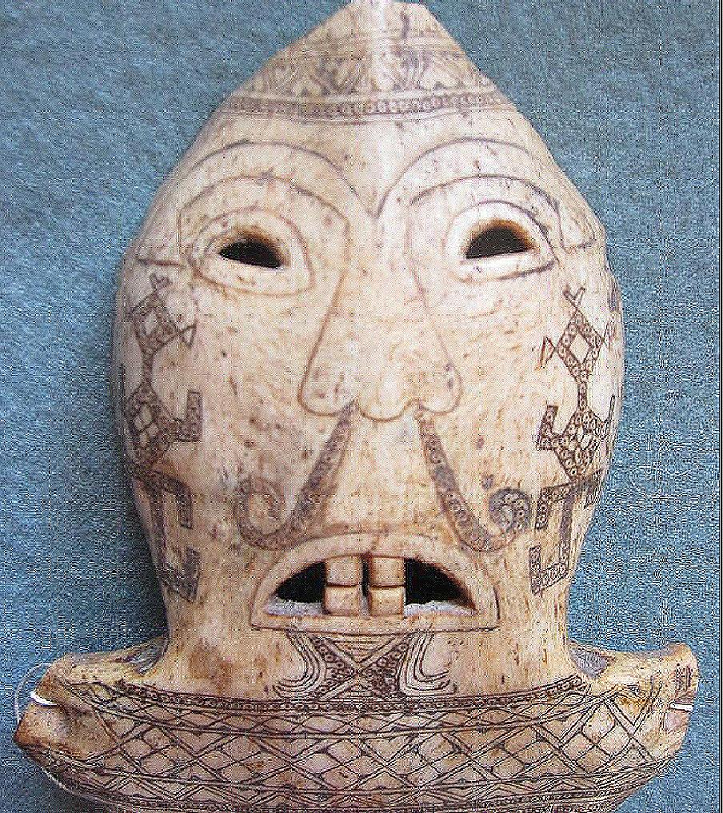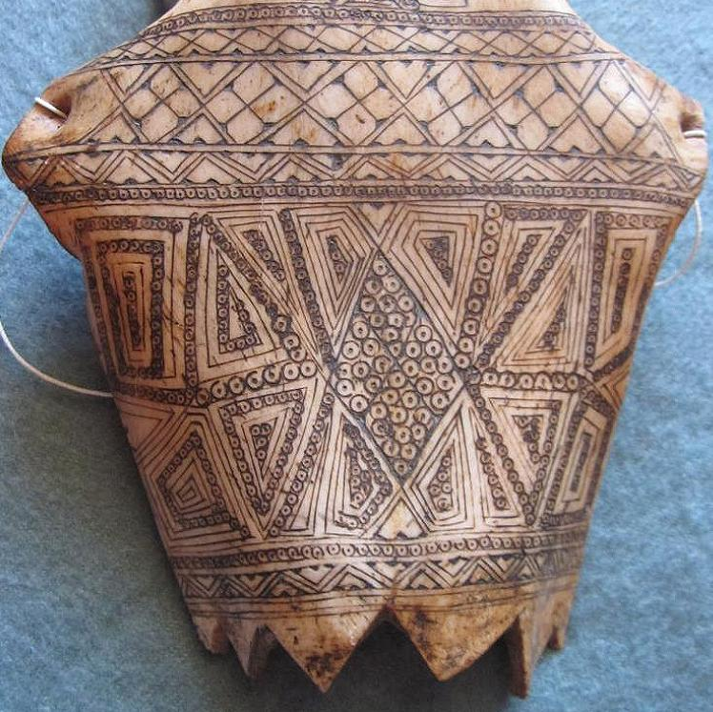

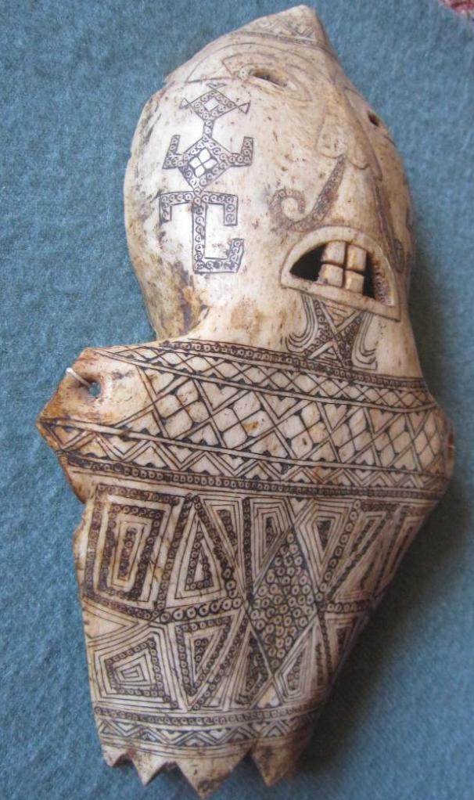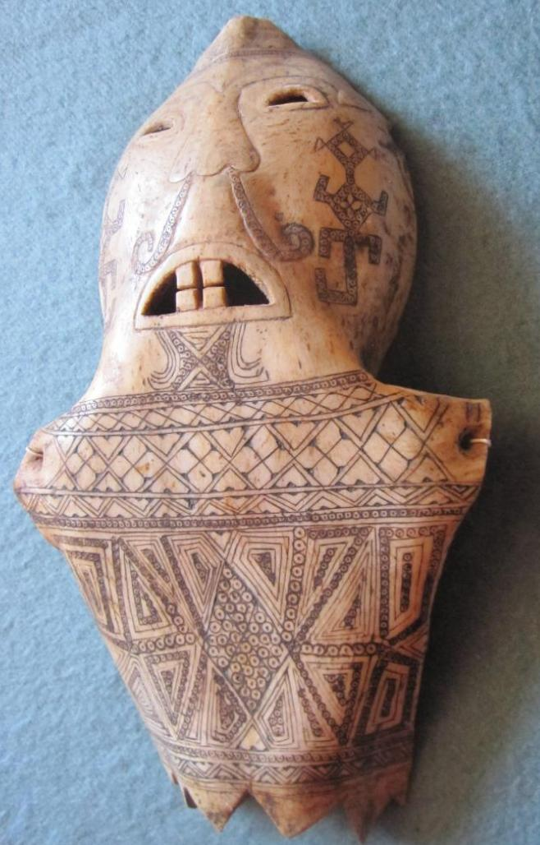

Figs. 1-7. Indo-Sumatra-Batak People-Shaman Mask-Water Buffalo Bone-1890’s

Case No.: Oceania

**Accession No.**

**Formal Label:** Indo-Sumatra-Batak People-Shaman Mask-Water Buffalo Bone-1890’s

**Display Description:**

The shape of the water buffalo bone was used to create this rare soul mask, incised and stenciled with an intricate, batik style tattoo that is traditional for the Batak culture of Indonesia.

This mask was intricately carved and affixed to the head of a shaman who would enunciate answers as an oracle to inquiring individuals.

**LC Classification: DS646.32**

**Date or Time Horizon: 1890’s**

**Map:**

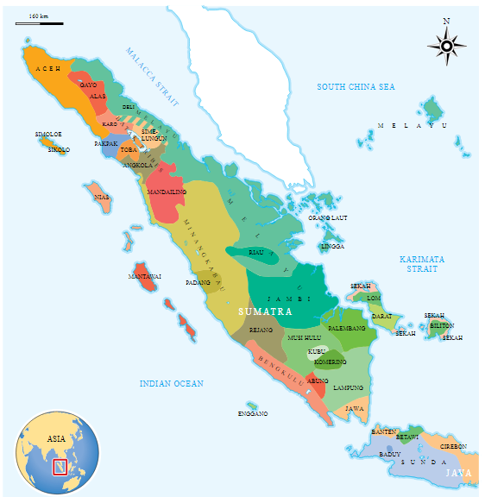

**GPS coordinates:**

**Cultural Affiliation:**

**Media: bone, pigment**

**Dimensions:**

**Weight:**

**Condition: original**

**Provenance:** French ethnological collection

**References:**

# Harrisson, T., 1959. Innermost Borneo: Ten Years' Exploration and Research. *The Geographical Journal*, *125*(3/4), pp.299-311.

# Harrisson, T., 1964. Inside Borneo: The Dickson Asia Lecture. *The Geographical Journal*, *130*(3), pp.329-336.

# KNAPEN, H., 2003. Innermost Borneo; Studies in Dayak cultures.

# Sather, C., 2003. Innermost Borneo: Studies in Dayak Cultures. *Asian Ethnology*, *62*(2), p.349.

# Sellato, B., 2002. How Tribes Come into Being: The Ethnogenesis of the Aoheng. *Innermost Borneo: Studies in Dayak Culture*, pp.163-194.

# Appendix:

Below are different representations of Headhunting warriors and Headhunting festivals after the return.



**Dayak Headhunters in Borneo, 1823**

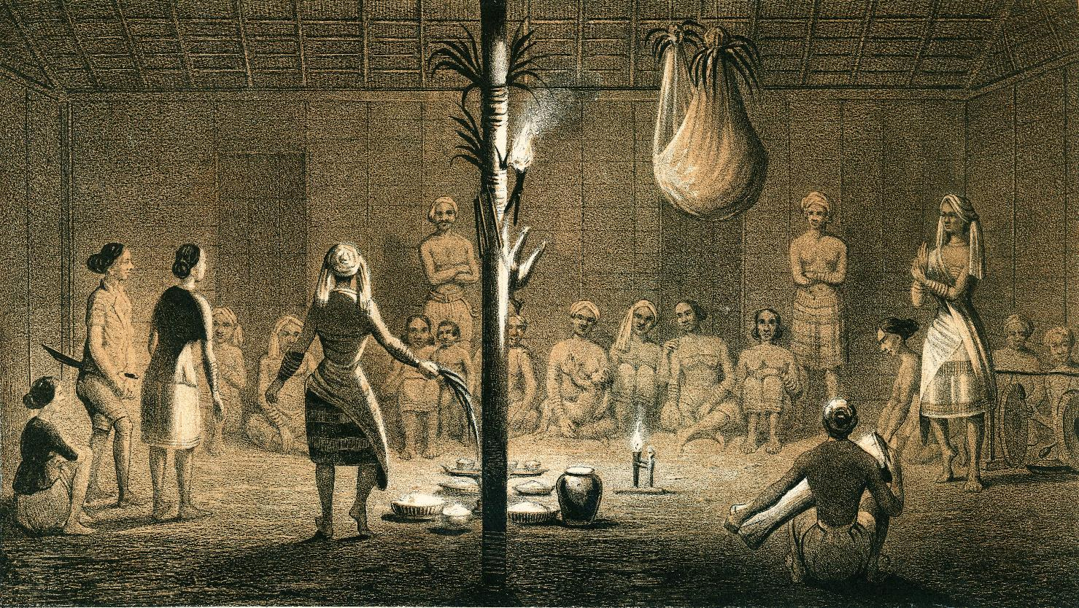

Dayak festival After C.A.L.M. Schwaner, 1846. Borneo. Ein Bilianfest der Dayak von Sungi Pattaym. Amsterdam, van Kampen.

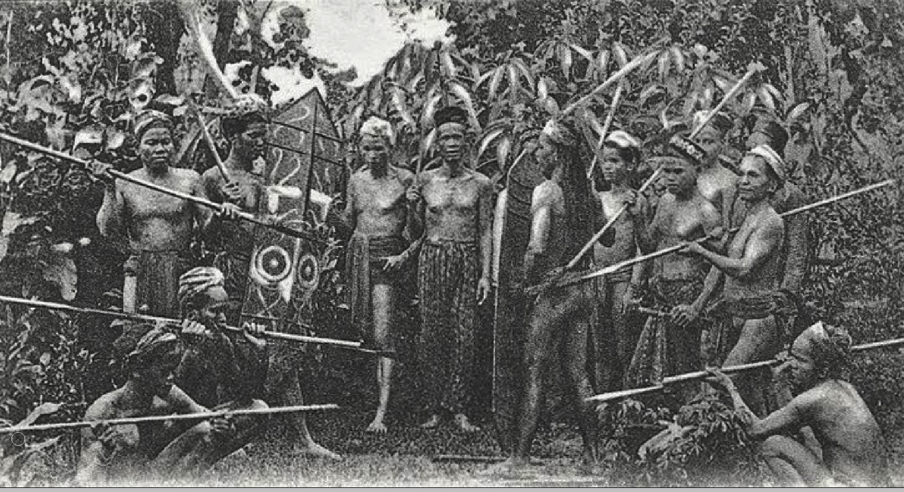

Groet uit Borneo, Ot Danoem. Head hunters in Borneo (Kalimantan), staged scene, from a postcard 1906



Head hunters in Borneo (Kalimantan), from a postcard 1920’s

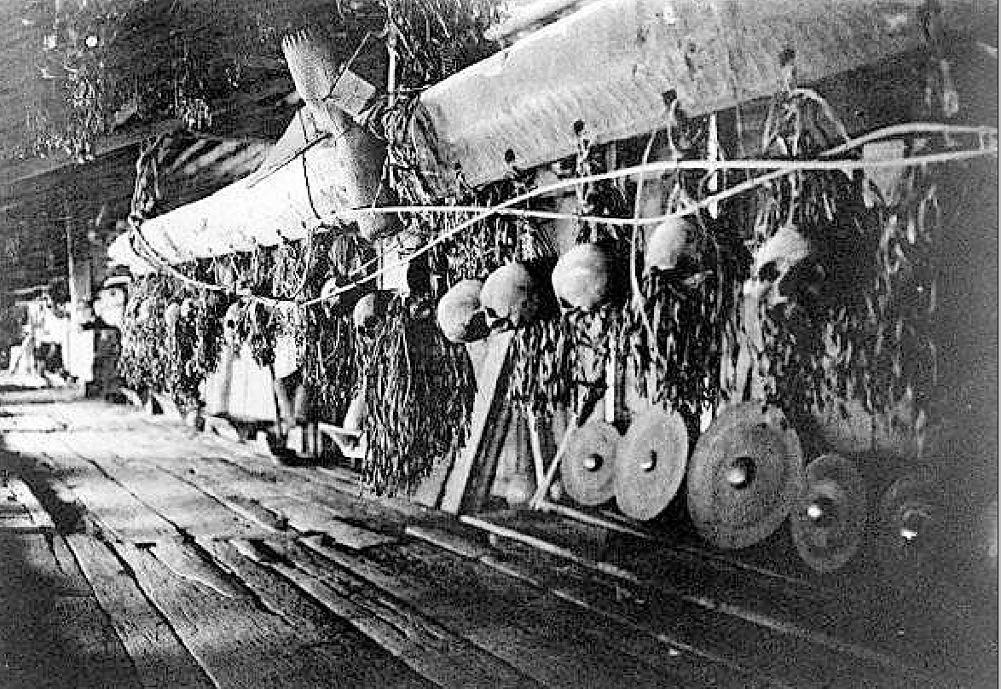

Headhunter s Gallery inside the house with skulls and Padaung Dayak weapons, which become wall hangings, 1900-1930.

**References:**

Schwaner, C.A.L.M. 1846. Borneo. *Ein Bilianfest der Dayak von Sungi Pattaym.* Amsterdam, van Kampen.